

UNIVERSITY OF BOTSWANA
FACULTY OF SCIENCE: COMPUTER SCIENCE DEPARTMENT
PROJECT REPORT 2025/26

SUPERVISOR: Dr T. Mapoka
CO-SUPERVISOR: Dr E.U. Okike
PROGRAMME: BSc Computer Science
Author: Pholoso Lekagane
ID: 202201649

Table of Contents
ABSTRACT 3
INTRODUCTION 4
PROBLEM STATEMENT 4
MOTIVATION 4
PROPOSED SOLUTION 4
PROJECT OBJECTIVES 4
PROJECT SCOPE 5
METHODOLOGY 6
DEVELOPMENT METHODOLOGY 6
ARCHITECTURE AND DESIGN OF SYSTEMS 6
COLLECTING REQUIREMENTS 6
PHASES OF DEVELOPMENT 6
METRICS FOR EVALUATION 7
TECHNOLOGIES AND TOOLS 7
LITERATURE REVIEW 8
FOUNDATION OF QUEUEING 8
METHODS FOR QUEUE ANALYSIS 8
OPTIMIZATION AND PERFORMANCE 9
APPLICATION TO VIRTUAL QUEUE MANAGEMENT 9
RESOURCES 11
HARDWARE 11
SOFTWARE 11
SCHEDULE 12
IMPLEMENTATION 13
OVERVIEW 13
ARCHITECTURE 14
BACKEND 15
USER DASHBOARD 15
STAFF DASHBOARD 16
KNOWN IMPLEMENTATION LIMITATIONS 16
TESTING REPORT 18
OVERVIEW 18
TEST RESULTS 18
SUMMARY 22
REFERENCES 23
APPENDIX 24
USER MANUAL 24
1. Introduction 24
2. Getting Started 25
3. User Guide 26
4. Staff Guide 30
5. Troubleshooting 36

ABSTRACT

Dealing with the endless lines of students at university services desks is a frustrating aspect that many students encounters. Time is Wasted standing in line, frustrated and without knowing how long they are going to have to wait or what paperwork they may need to bring. To overcome this problem, this project will design a new digital queue management system for the University of Botswana. This system enables students to access a service queue through any device that has an enabled web browser.

The application is structured within three components: a Spring boot REST API which manages all backend operations Logic and interaction with the database (a student facing web dashboard created in React Native and Expo,) and a standalone staff portal using the same technology and data persistence is provided by MySQL, with Hibernate taking care of the database schema.

INTRODUCTION

PROBLEM STATEMENT
The finance office of the Universirty of Botswana tends to have a large volume of people queueing for help throughout the semester. This causes congestion at the office and it slows down the workflow as well as wasting the time of the people queueing for help.

MOTIVATION
The idea is to create a system that allows people to queue for help at the office without having to physically wait outside the office so that they can still get other things on their agenda done while also making it easier for staff members to deal with the workload they have.

PROPOSED SOLUTION
The solution being propsed is a system named UB Queue Management System that can be used by anyone looking for help in any University of Botswana Administrative office and not just the finance offices to queue for help without being physically being present and only needing to show up when their time to be assited arrives. This system will be in the form of a web interface that can be accessed on the the University of Botswana’s website by a person seeking assitance and another interface for the staff in the administrative offices to interact with the system while assisting the customer.

PROJECT OBJECTIVES
- To develop an easy to access online queuing system to reduce physical congestion at the administrative offices of the University of Botswana
- To improve the workflow of staff by reducing the time spent on managing a walk-in queue
- To allow individuals the ability to better spend their time by queueing remotely and only needing to show up when their time arrives
- To create a system that can be used through the whole institution and not just one particular office of section of the administration

PROJECT SCOPE

The goal of this project is to create a web-based queue management system with two interfaces for the administrative offices of the University of Botswana. The system will have an administrative interface for office staff to effectively manage and process queues, as well as a customer-facing interface that can be accessed via the university website, enabling staff and students to join lines remotely. The finance office will be the primary focus of the initial implementation, but the design will allow for future expansion to other university administrative departments. System design, development, testing, and deployment will all be covered by the project; however, hardware purchases and changes to the university's current infrastructure beyond software integration with the current website will not be included.

METHODOLOGY

DEVELOPMENT METHODOLOGY
Using iterative development cycles to guarantee ongoing feedback and improvement, the project will adhere to an Agile development methodology. Throughout the development process, this method enables adaptability to user requirements and technical difficulties.

ARCHITECTURE AND DESIGN OF SYSTEMS
A client-server architecture will be used in the system's design, and it will have two main web interfaces: one for customers and another for administrative staff. A database management system will be used by the backend to store user data, transaction logs, and queue information. To guarantee accessibility on a range of devices, including desktop computers, tablets, and smartphones, the frontend will be created utilising responsive web design principles.

COLLECTING REQUIREMENTS
Initial prerequisites will be gathered by:
- Interviews with finance office staff to understand current workflows and pain points
- Surveys distributed to students to gather user expectations and preferences
- Observation of current queuing patterns at the finance office during peak and off-peak hours
- Analysis of existing queue management systems used in other institutions

PHASES OF DEVELOPMENT
Phase 1: Prototyping and Design - Wireframes and UI mockups for staff and customer interfaces are created, and then prototypes are developed for user testing and feedback gathering.

Phase 2: Development of the Core System - User registration, queue joining, position tracking, notification systems, and staff queue management tools are among the crucial features that have been implemented.

Phase 3: Evaluation and Improvement - thorough testing that includes performance testing to make sure the system can manage anticipated user loads, unit testing, integration testing, and user acceptance testing with a sample group of employees and students.

Phase 4: Training and Deployment - Promotional materials to promote student adoption, training sessions for administrative staff, user documentation creation, and a pilot implementation at the finance office.Phases of Development

METRICS FOR EVALUATION
The effectiveness of the system will be evaluated by:
- decrease in office congestion and actual wait times
- Average wait time in comparison to the manual system that was in place before
- Staff and student user satisfaction surveys
- Statistics on system dependability and uptime
- Daily user count in comparison to baseline data

TECHNOLOGIES AND TOOLS
The development will make use of contemporary web technologies such as HTML5, CSS3, and JavaScript for the front end. The database system and backend framework will be chosen based on compatibility with the university's IT infrastructure. The system will be hosted on university servers or authorised cloud infrastructure, and Git will be used to manage version control.

LITERATURE REVIEW

FOUNDATION OF QUEUEING
Queuing theory provides the mathematical framework for analyzing waiting lines and service systems. Thomopoulos (2013) explains that queuing systems are characterized by several key components: the arrival process, the service mechanism, the queue discipline, and the system capacity. In the context of university administrative offices, these components translate to student arrivals, service time at help desks, the order in which students are served, and the physical or virtual capacity of the waiting area.
Arrival rate (λ) and service rate (μ) are the two basic parameters of any queuing system, and they work together to determine system performance metrics like average waiting time, queue length, and system utilisation (Thomopoulos, 2013). Designing a successful virtual queue management system requires an understanding of these parameters since they aid in forecasting how the system will behave under different load scenarios. According to Thomopoulos (2013), systems where λ approaches μ have noticeably longer wait times, highlighting the direct impact that the relationship between arrival and service rates has on customer satisfaction and operational efficiency.

METHODS FOR QUEUE ANALYSIS
In order to analyse and optimise queuing systems, statistical methods are essential. Thomopoulos (2013) talks about a number of probability distributions that are frequently used in queuing analysis, such as the exponential distribution for service times and the Poisson distribution for arrival processes. System designers can forecast system performance under various conditions and model real-world scenarios with the help of these statistical tools. Statistical analysis aids in capacity planning and resource allocation for university administrative offices, where arrival patterns may differ substantially between peak times (like registration weeks) and regular operations (Thomopoulos, 2013).
Statistical techniques are also used in performance evaluation, where metrics like average waiting time, average queue length, and system utilisation are computed and examined (Thomopoulos, 2013). These metrics are crucial for both evaluating the success of a virtual queue management system after it has been deployed and for defending its deployment.

OPTIMIZATION AND PERFORMANCE
Anisimov (2009) and Thomopoulos (2013) both stress how crucial system optimisation is for queuing applications. Thomopoulos (2013) offers strategies for figuring out the ideal service capacity and striking a balance between the expenses of providing services and the costs of waiting times for customers. For university administrators who need to defend resource allocation choices, this economic viewpoint is helpful. According to the author, when the system runs close to capacity, even minor adjustments to service rate or queue management can result in significant drops in average waiting times.
Anisimov (2009) extends this discussion by examining dynamic queuing systems where parameters may change over time, which is highly relevant to university operations that experience seasonal variations in demand. The ability to model and predict these variations allows for proactive management strategies, such as adjusting staffing levels or implementing appointment systems during peak periods.

APPLICATION TO VIRTUAL QUEUE MANAGEMENT
A real-world implementation of queuing theory that overcomes many conventional constraints is the switch from physical to virtual queuing systems. According to Thomopoulos (2013), queuing systems can be made more efficient by decreasing the perceived waiting time even when the actual service time stays the same. By enabling users to do other things while they wait, virtual queue management successfully removes the psychological toll that physical waiting takes.
Additionally, Anisimov (2009) emphasises the significance of information transparency in queuing systems, pointing out that when customers have access to information about queue status and anticipated wait times, their perceptions of fairness and satisfaction levels improve. This psychological aspect of queuing that goes beyond mathematical models can be addressed by a web-based queue management system, which can offer real-time updates on queue position and estimated service times.

RESOURCES

HARDWARE
- A computer for development
- Mobile device for testing

SOFTWARE
- IDE: Visual Studio Code
- Java: JDK 21+
- Maven:3.8+
- Node.js: 18+
- Npm: 9+
- DBMS: MySQL 8.0
- Web Development Libraries: React
- Version Control System: GitHub
- Project Tracker

SCHEDULE

TASK |  | PROGRESS | START | END
Requirements Gathering and Analysis
Staff Interviews |  | 100% | 2/12/26 | 2/15/26
Student Interviews |  | 100% | 2/15/26 | 2/17/26
Office Observation |  | 100% | 2/17/26 | 2/21/26
Design and Prototyping
Wireframes |  | 100% | 2/18/26 | 2/23/26
Database Design |  | 100% | 2/20/26 | 2/25/26
Prototype Design |  | 100% | 2/26/26 | 3/3/26
Prototype Development |  | 100% | 3/4/26 | 3/12/26
System Development
Frontend Dev |  | 100% | 3/14/26 | 3/28/26
Backend Dev |  | 100% | 3/29/26 | 4/12/26
Intergration |  | 100% | 4/13/26 | 4/27/26
Testing and Deployment
Unit Testing |  | 100% | 4/29/26 | 5/6/26
Intergration Testing |  | 100% | 5/6/26 | 5/13/26
Deployment |  | 90% | 5/13/26 | 5/18/26

IMPLEMENTATION

OVERVIEW
The UB Queue Management System was implemented as a three-tier application comprising a Spring Boot REST API backend, a student-facing React Native mobile/web application (User Dashboard), and a staff-facing React Native mobile/web application (Staff Dashboard). All three tiers were developed and tested concurrently, with the backend exposing a consistent JSON API that both frontends consume over HTTP.

ARCHITECTURE

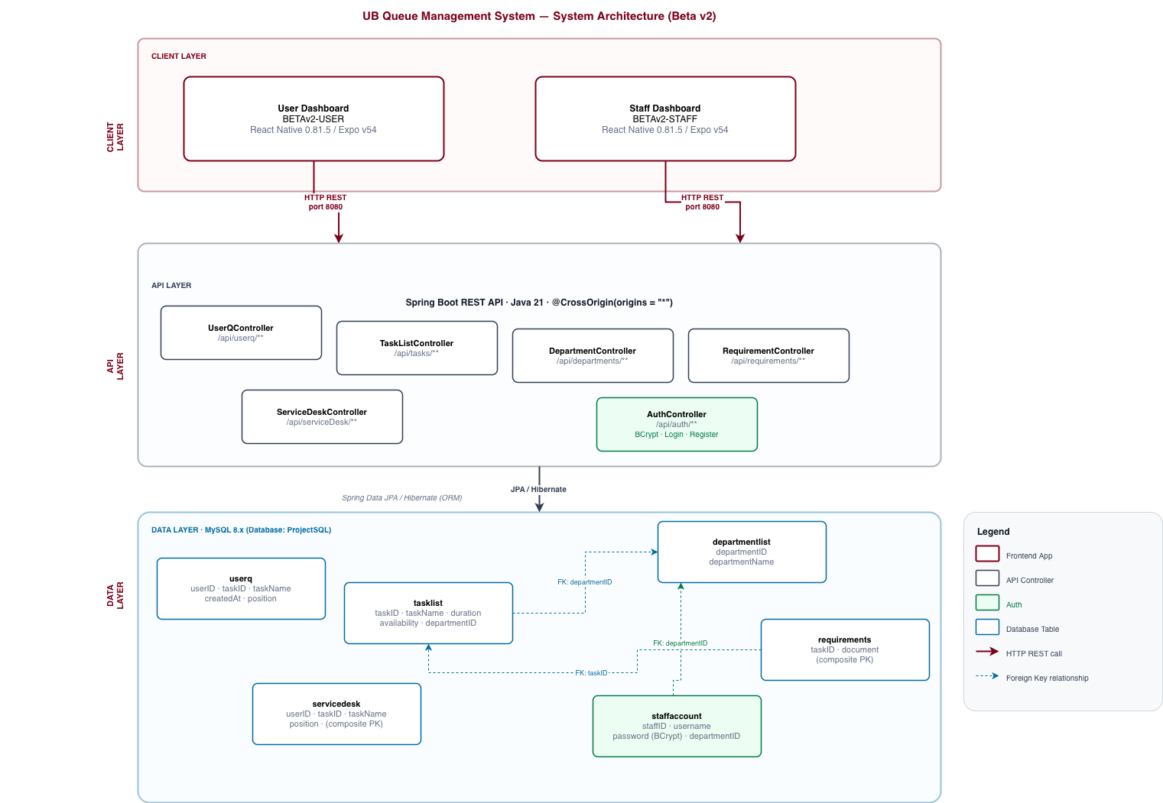

BACKEND
The backend is a Spring Boot 4.0.3 application written in Java 21, using Spring Data JPA with Hibernate as the ORM layer and MySQL 8 as the database. Maven is used for dependency management. The application exposes five REST controllers, each mapped to a dedicated resource path under /api;
- UserQ Controller
- TaskList Controller
- Department Controller
- Requirement Controller
- Auth Controller

Data models are defined as JPA entities with Lombok-generated getters and setters. Two entities use composite primary keys: Requirements (taskID + document) and ServiceDesk (userID + taskID), both implemented with a separate @Embeddable key class. The StaffAccount entity introduced in Beta v2 links each staff member to a DepartmentList record via a @ManyToOne relationship, allowing the login response to return department context directly. Passwords are stored as BCrypt hashes; plain-text credentials are never persisted.
The database schema is managed by JPA with ddl-auto=update, which creates or alters tables on application startup. A ‘sample_data.sql’ sql script is provided to populate all tables of the database with mock data.

USER DASHBOARD
The User Dashboard is a React Native 0.81.5 / Expo v54 application targeting both web and mobile. It is structured as a three-screen native stack navigator.
Component | Implementation Detail
UserWelcomeScreen | Landing page. Renders a split-panel layout on tablet/desktop and a centred card on mobile
JoinScreen | Fetches departments on mount, then tasks per department on selection. All tasks appear in the picker; unavailable ones show an inline warning banner. On submit, POST /api/userq/queue is called and the user is navigated directly to StatusScreen with the returned userID pre-loaded.
StatusScreen | Accepts an initialUserID route param for auto-load after joining. Fetches queue details and position in parallel. The cancel flow calls DELETE /api/userq/remove/{userID} and removes queue enttry.

STAFF DASHBOARD
The Staff Dashboard shares the same technology stack and navigation pattern. It consists of three screens navigated by a native stack.
Component | Implementation Detail
WelcomeScreen | Username/password login form. Calls POST /api/auth/login; on success, navigates to StaffDashboard passing departmentID, departmentName, staffID, and username as route params. Error messages from the API are displayed inline.
StaffDashboard | Receives department context from route params. Fetches /api/userq/department/{departmentID} on mount. Renders a queue list sorted by time of entry.
ManageTasks | Loads all tasks and their requirements. Supports creating tasks (POST /api/tasks/add), updating (PUT /api/tasks/update/{id}), cascading delete (DELETE /api/tasks/delete/{id}), and adding/removing individual document requirements (POST /api/requirements/add, DELETE /api/requirements/delete/{taskID}/{doc}).

KNOWN IMPLEMENTATION LIMITATIONS
Several areas were intentionally deferred for post-beta resolution. The staff login validates credentials with BCrypt but issues no token, leaving API endpoints unprotected after login. The /api/auth/register endpoint has no admin guard. Queue user IDs are generated as random 5-digit integers, which could theoretically collide under high concurrency. All communication is plain HTTP with hardcoded localhost addresses in frontend constants. The ddl-auto=update JPA setting is suitable for development but should be replaced with a migration tool such as Flyway before any production deployment.

TESTING REPORT

OVERVIEW
This report covers testing done on the queue management system. All 38 test cases were run across the three system components -User Dashboard, Staff Dashboard, and the backend API.
Total Cases | Passed | Failed | N/A
35 | 33 | 0 | 2

35 tests passed. The 2 marked N/A were the live position alert cases (TC-USER-15, TC-USER-16), which require a live multi-user queue and the implementation of a notification system.

TEST RESULTS
User Dashboard
TC ID | Description | Result
TC-USER-01 | Welcome screen loads -logo, title, and both buttons visible | PASS
TC-USER-02 | Join the Queue button navigates to Join Screen | PASS
TC-USER-03 | Check Queue Status button navigates to Status Screen | PASS
TC-USER-04 | Joining a queue navigates directly to Status Screen with Queue ID pre-loaded | PASS
TC-USER-05 | Join button stays disabled until a task is selected | PASS
TC-USER-06 | Selecting an unavailable task shows a warning banner | PASS
TC-USER-07 | Switching department clears and reloads the task list | PASS
TC-USER-08 | Offline backend shows error message on Join Screen | PASS
TC-USER-09 | Queue details display correctly when a valid ID is entered | PASS
TC-USER-10 | Leave Queue removes the entry after confirmation | PASS
TC-USER-11 | Non-existent Queue ID shows a not-found error alert | PASS
TC-USER-12 | Tasks with no documents show "No specific documents required." | PASS
TC-USER-13 | Queue ID field only accepts numeric input | PASS
TC-USER-14 | "Almost Your Turn" alert is sent to user when position drops to 3 | N/A  Notifications have not been implemented due to resource constraints
TC-USER-15 | "You're Next!" alert is sent to user when they are position 1 | N/A  Notifications have not been implemented due to resource constraints
TC-USER-16 | After joining, Status Screen auto-loads with correct Queue ID | PASS

Staff Dashboard
TC ID | Description | Result
TC-STAFF-01 | Valid credentials log in and open the correct department queue | PASS
TC-STAFF-02 | Wrong credentials show an error -no navigation occurs | PASS
TC-STAFF-02B | Submitting empty login fields shows a validation message | PASS
TC-STAFF-03 | Queue list auto-refreshes every 10 seconds | PASS
TC-STAFF-04 | Manual Refresh button updates the list immediately | PASS
TC-STAFF-05 | Serve / Remove removes the user from the queue | PASS
TC-STAFF-06 | Empty queue shows "Queue is empty" state | PASS
TC-STAFF-07 | Queue is sorted by join time -oldest entry first | PASS
TC-STAFF-08 | New task is created and appears in the task list | PASS
TC-STAFF-09 | Toggling availability updates the task globally | PASS
TC-STAFF-10 | Adding a document requirement saves and displays correctly | PASS
TC-STAFF-11 | Removing a document requirement removes it immediately | PASS
TC-STAFF-12 | Deleting a task, cascades to its requirements and queue entries | PASS
TC-STAFF-13 | Only one task card expands at a time | PASS

Backend API
TC ID | Description | Result
TC-API-01 | GET /departments/all -returns all 5 departments | PASS
TC-API-02 | GET /tasks/department/{id} -returns only tasks for that department | PASS
TC-API-03 | POST /userq/queue -creates entry with auto-generated 5-digit userID | PASS
TC-API-04 | GET /userq/position/{id} -returns correct integer position | PASS
TC-API-05 | DELETE /userq/remove/{id} -removes entry and returns 200 OK | PASS
TC-API-06 | GET /tasks/all -returns all tasks with nested department objects | PASS
TC-API-07 | GET /requirements/task/{id} -returns correct document list | PASS
TC-API-08 | POST /auth/login -valid credentials return staff + department info | PASS
TC-API-09 | POST /auth/login -wrong password returns 401 | PASS
TC-API-10 | POST /auth/login -missing fields return 400 | PASS
TC-API-11 | POST /auth/register -duplicate username returns 409 | PASS

SUMMARY

This project focus on solving an issue of workflow efficiency in the University of Botswana for services that often have a high volume of people using them while also helping said people improve the way they manage their time when they plan to use the services of the university.
The system that has been built is indeed able to increase the effieciency of the workflow through giving users of these services a high level view of how things are proceeding within the queue. This enables them to plamn well ahead of time so the may be able to multitak and/or take care of other things without worrying about wasting their own time.

REFERENCES

- Anisimov, V. (2009). Queueing Theory 1: Advanced Trends. ISTE Ltd and John Wiley & Sons Inc.
- Thomopoulos, N. T. (2013). Fundamentals of Queuing Systems: Statistical Methods for Analyzing Queuing Models. Springer Science+Business Media.

APPENDIX

USER MANUAL

1. Introduction

The UB Queue Management System lets University of Botswana students and non-students join department service queues digitally - without standing in a physical line. Users receive a Queue ID, track their position in real time, and are notified when it is almost their turn.
Departmental staff use a separate app to monitor the live queue, serve students, and manage the services on offer.

There are two apps:
App | User | Function
User Dashboard | Students/Visitors | Join Queues and check position
Staff Dashboard | Department Staff | Manage queues and serve users

2. Getting Started

Both web app can run on either a mobile device or a web browser on a computer
Requirements:
- A device with a modern web browser
- Access to the university's local network (the backend must be reachable)
Accessing the apps:
- Open the provided URL or scan the QR code shown when the app is started.

3. User Guide

3.1 Welcome Screen

When you open the User Dashboard you will see the Welcome Screen.
On desktop/tablet: A split layout appears -the left side shows the University of Botswana branding; the right side shows two action buttons.
On mobile: A white card is centred on a maroon background with the same two buttons.
Button | Use
Join Queue | Takes user to a screen for joining a queue
Check Status | Takes user to a screen for checking their position

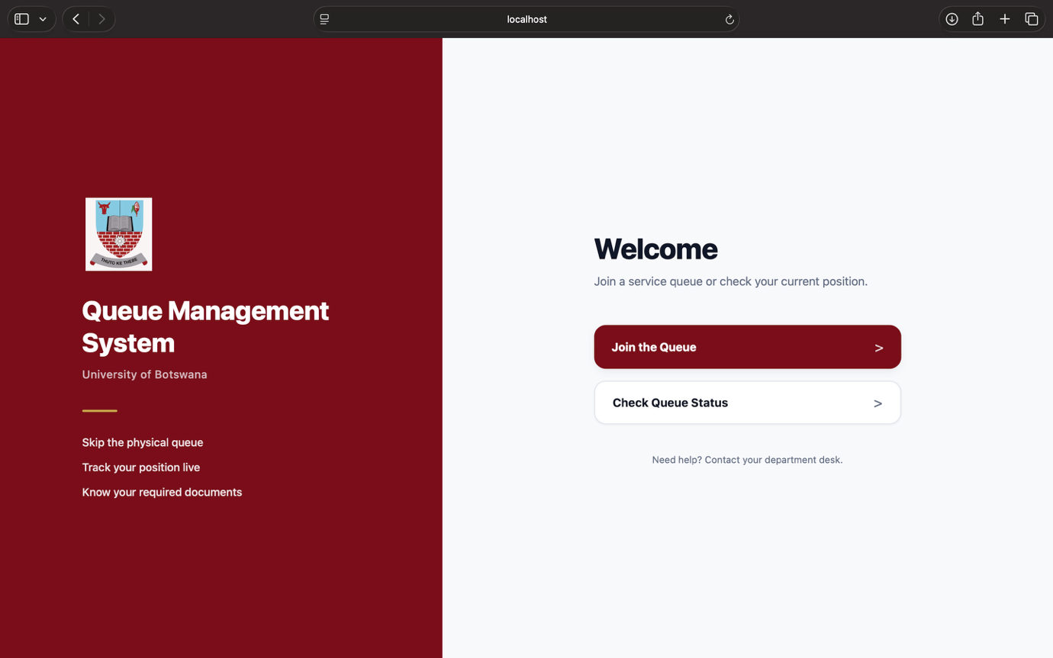

3.2 Joining a Queue

- From the Welcome Screen, tap Join the Queue.
- On the Join Screen, use the first dropdown to select your Department (e.g. Finance Office, Registrar's Office).
- After selecting a department, the Service dropdown becomes active. Choose the service you need.
- If a service shows an orange warning banner ("This service is currently unavailable"), it cannot be joined at this time. Select a different service or visit the desk directly.
- Tap Join Queue.
- You are automatically taken to the Status Screen with your Queue ID already loaded and your current position displayed.
Note: Users should write down or remember their Queue ID. They will need it if they close the app and want to check their position later.

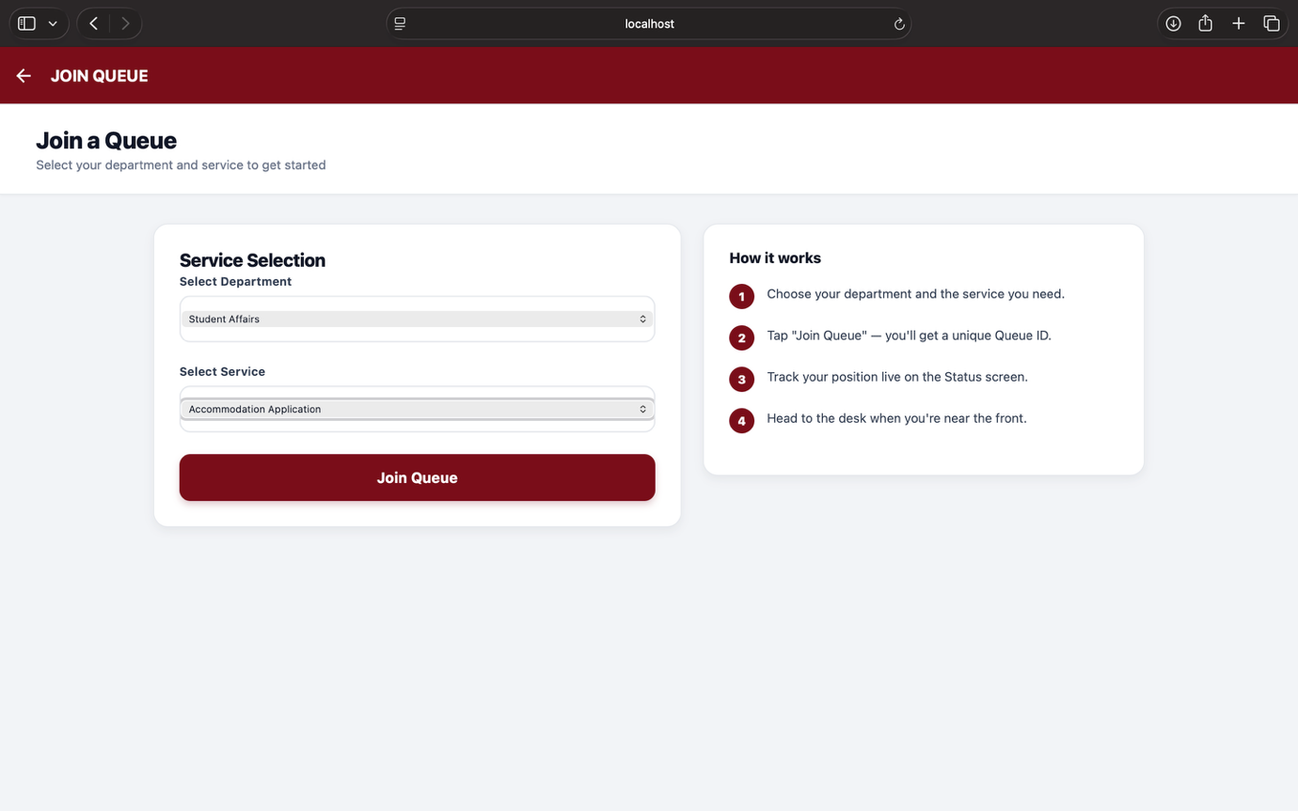

3.3 Checking Your Queue Status

If you already have a Queue ID (e.g. you joined earlier):
- From the Welcome Screen, tap Check Queue Status.
- Enter your Queue ID in the text field (numbers only).
- Tap View Queue Details.
The Status Screen shows:
Detail | Description
Current Position | User’s current position in the queue
Task/Service | The service the user has queued for
Queue ID | User’s unique identifier
Joined | The time the user joined the queue
Required Documents | Shows the documents needed

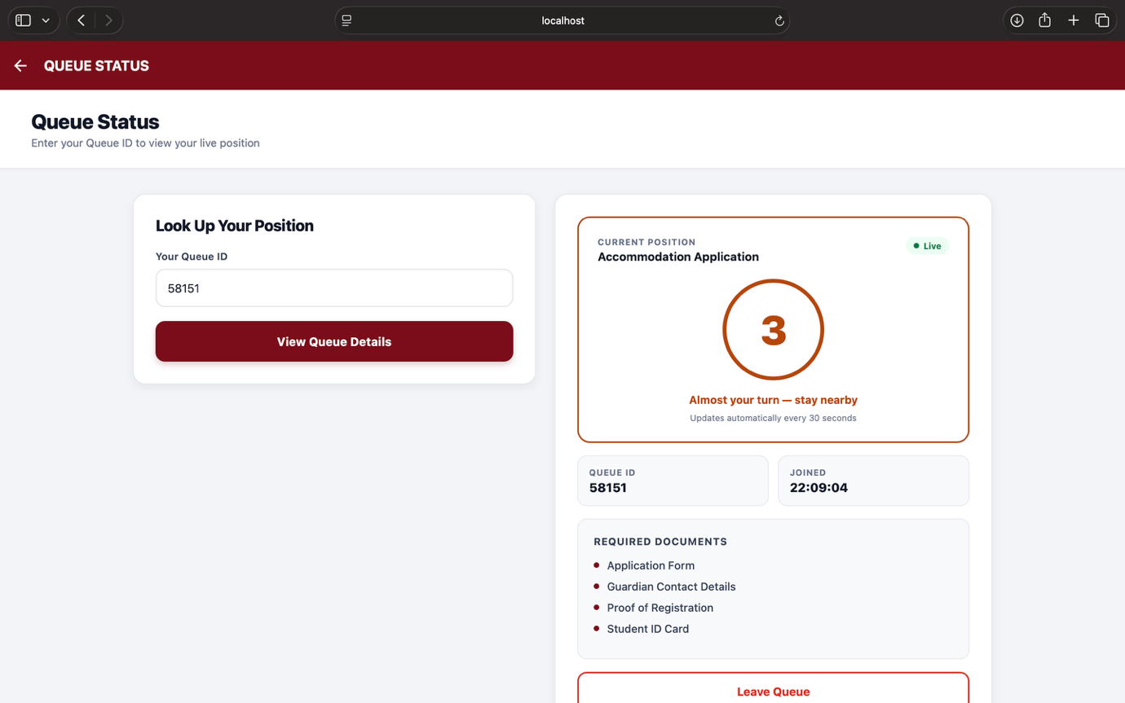

3.4 Leaving the Queue

If you no longer need to be served:
- On the Status Screen, tap Leave Queue.
- A confirmation dialog appears. Tap Yes, Cancel to confirm, or Keep My Place to stay in the queue.
- On success, your queue entry is removed and the status display clears.

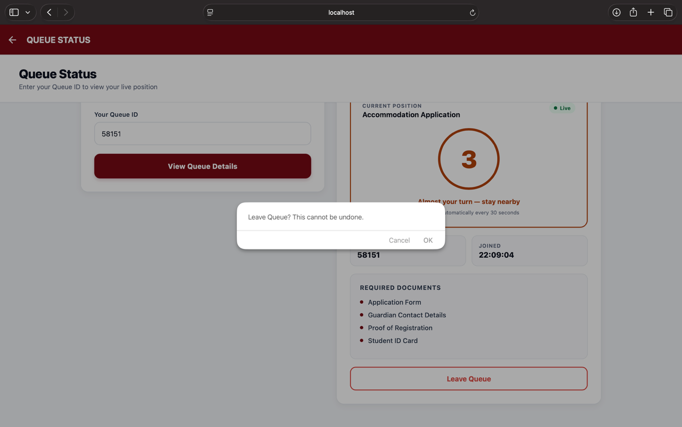

4. Staff Guide

4.1 Logging In
- Open the Staff Dashboard app.
- Enter your Username and Password.
- Tap Login.
On success, you are taken directly to the queue view for your department. Your login credentials are linked to a specific department -you will only see the queue for that department.
If login fails: Double-check your username and password. Contact your system administrator if you have forgotten your credentials or do not have an account.
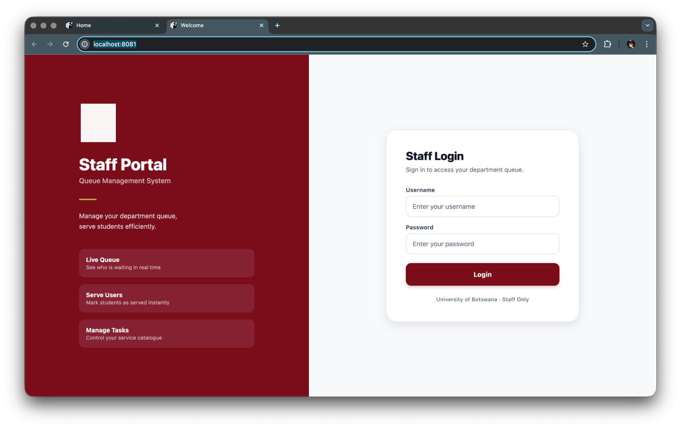

4.2 Viewing the Live Queue

After logging in, the Staff Dashboard screen shows all users currently waiting in your department's queue.
Each queue card displays:
Detail | Description
Queue ID | A user’s unique identifier
Service | Service that the user is waiting for
Position | The user’s place in the queue
Joined | The time the user joined

The queue auto-refreshes every 10 seconds. You can also tap Refresh to update immediately. If nobody is waiting, the screen shows: "Queue is empty."
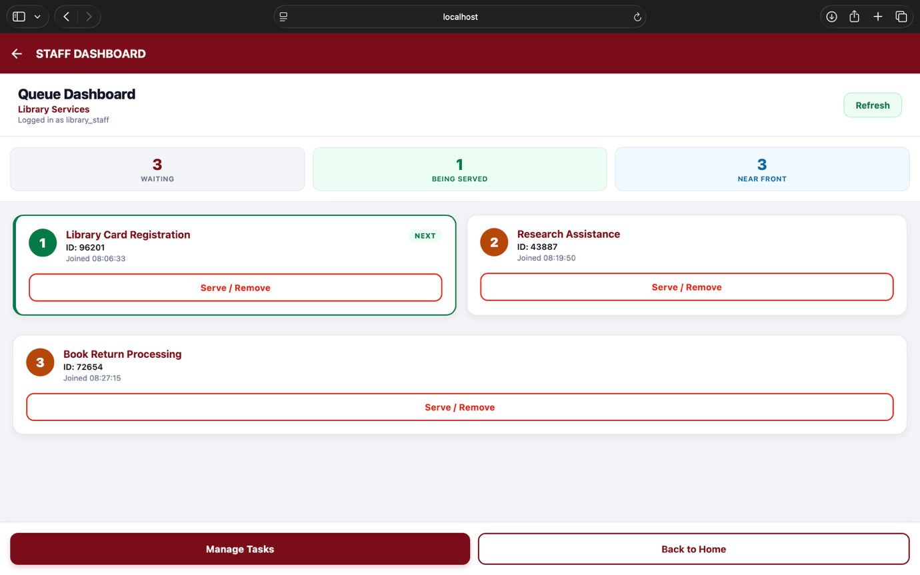

4.3 Serving/Removing a User

When you are ready to serve the next user:
- Find their card
- Tap Serve / Remove on their card.
- Confirm by tapping OK in the dialog.
- The student is removed from the queue and the list updates.

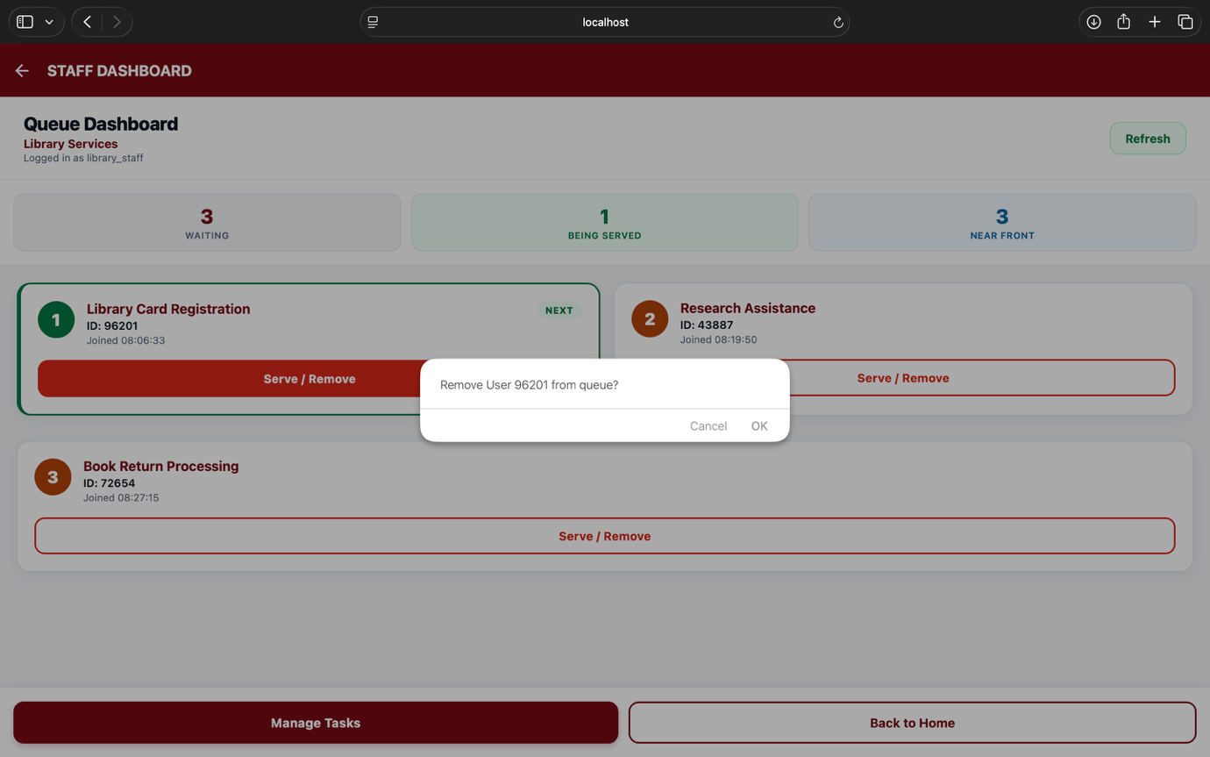

4.4 Managing Tasks and Services

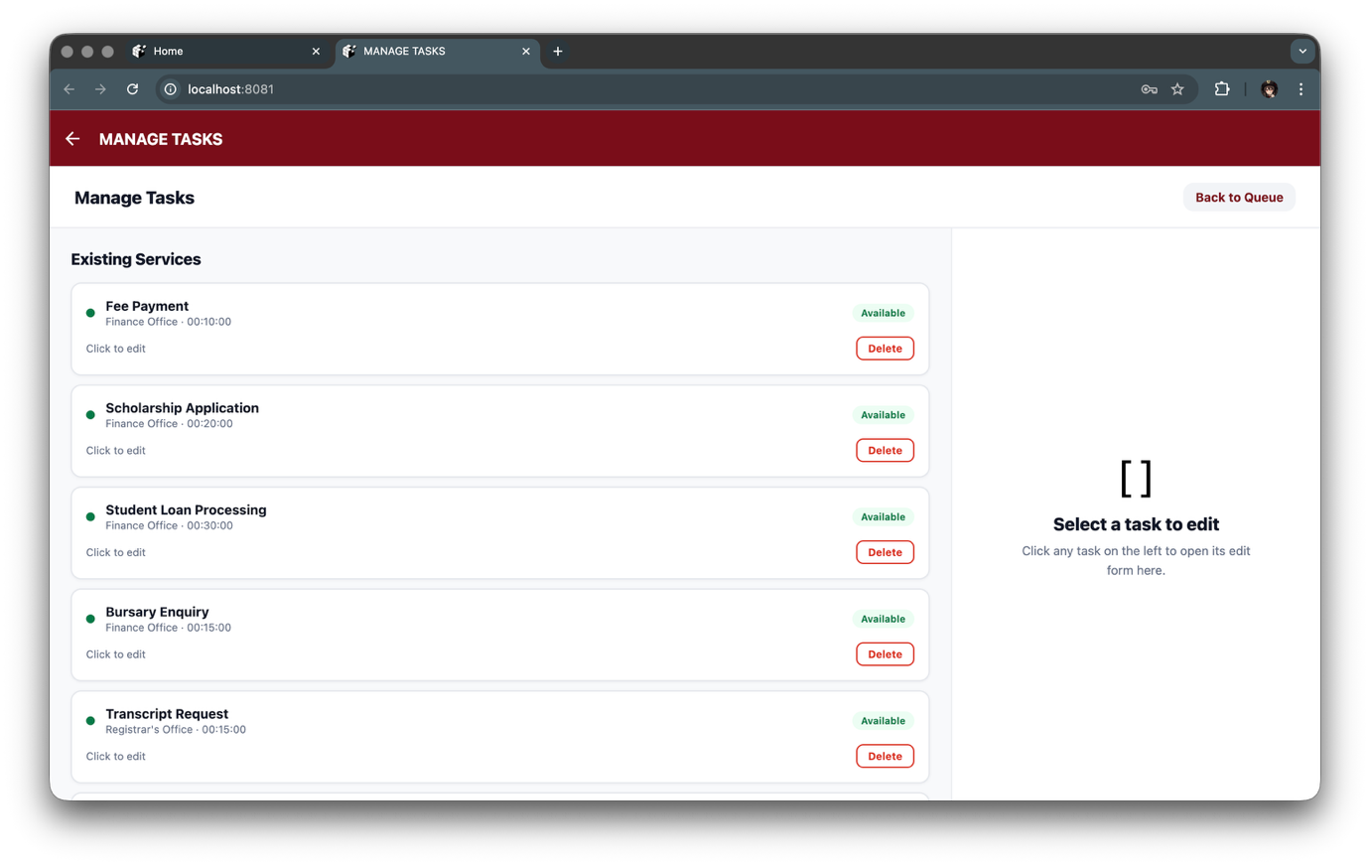

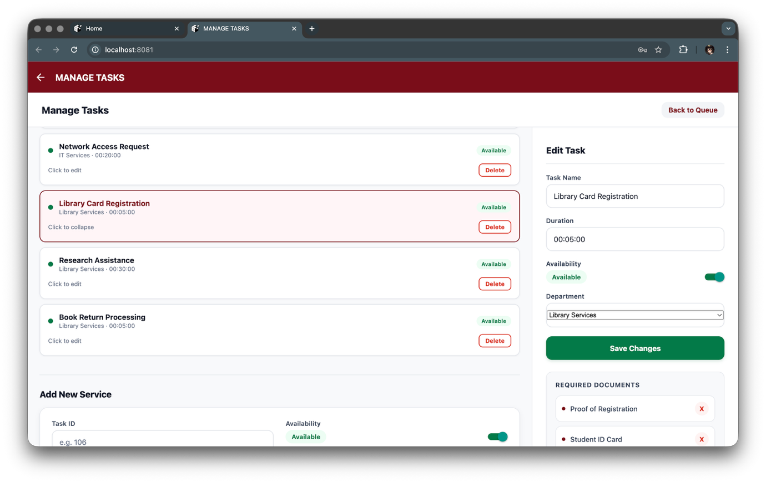

From the Staff Dashboard, tap Manage Tasks to open the Task Manager.
Viewing Existing Tasks
All tasks for all departments are listed as collapsible cards. Tap a card header to expand it and see its details and requirements.

Editing a Task
- Expand the task card.
- Update any fields: Task Name, Duration (HH:MM:SS format), or Availability (toggle on/off).
- Tap Save Changes.
Changing Availability to Unavailable hides the service from students on the Join Screen -they will see a warning if they somehow select it.

Deleting a Task
- Expand the task card.
- Tap Delete.
- Confirm by tapping OK.

Adding a New Task

- Fill in the New Task form at the bottom of the screen:
  - Task ID: a unique number you assign manually
  - Task Name: the service name students will see
  - Duration: estimated time
  - Availability: whether it appears as joinable
  - Department: the department this task belongs to
- Tap Create Task.

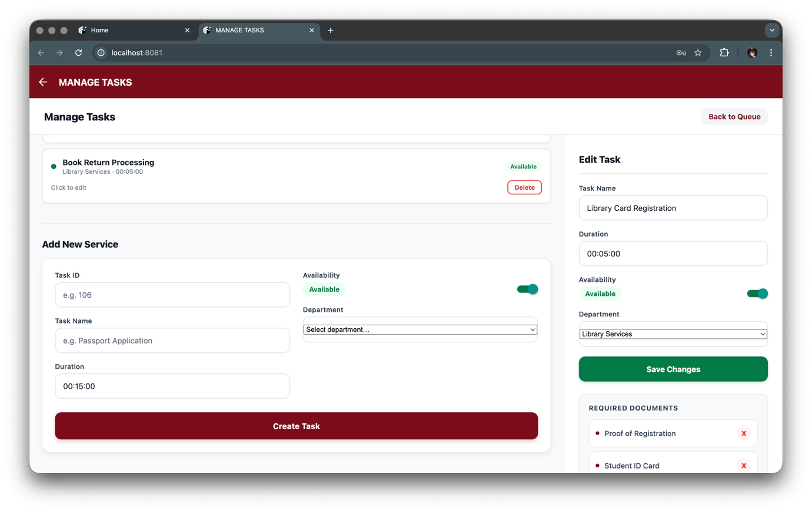

Managing Required Documents
Each task can have a list of documents students must bring.

To add a document:
- Expand the task card.
- Type the document name in the requirements text field (e.g. "Student ID Card").
- Tap Add.

To remove a document:
- Expand the task card.
- Tap the ‘X’ button next to the document you want to remove.

5. Troubleshooting

Problem | Likely Cause | Action
"Error loading departments" on Join Screen | Backend is not running | Ensure the Spring Boot backend is started and reachable
"Could not reach the server" on Status Screen | Network issue or server offline | Check your network connection; confirm the backend is running
"No one with that Queue ID is currently in the queue" | ID does not exist or was already served | Verify the ID is correct; you may have already been served
Staff login returns "Invalid username or password" | Wrong credentials | Check for typos; contact the system administrator
Queue position not updating | Auto-poll is running (30s interval) | Wait up to 30 seconds; or close and reopen the Status Screen
Tasks not showing on Join Screen | All tasks are marked Unavailable, or no tasks exist for the department | Ask staff to check task availability via the Staff Dashboard
Staff Dashboard shows blank queue | No users have joined yet, or queue was cleared | This is expected -wait for students to join

